Zahava Gopin

WEB 335: Assignment 2.2

3/21/23

**NodeShopper**

*create ORD’s to represent the business rules:*

*Convert the proposed ORDs into NoSQL data structures:*

1. a CUSTOMER can have many INVOICE(s)
2. many INVOICE(s) are assigned to a CUSTOMER

{

"_id": "123",

"firstName": "John",

"lastName": "Smith",

"dateOfBirth": "1/2/03",

"username": "JS03",

"invoices": [{

"_id": "123",

"createDate": "3/21/23",

"shipDate": "3/22/23",

"subtotal": "107.89",

"itemId": "1"

},

{

"_id": "123",

"createDate": "3/24/23",

"shipDate": "3/25/23",

"subtotal": "236.99",

"itemId": "2"

}

]

}

1. an INVOICE can have many LINEITEM(s)
2. many LINEITEMs are added to an INVOICE

{

"_id": "123",

"createDate": "3/21/23",

"shipDate": "3/22/23",

"subtotal": "107.89",

"qty": "1",

"lineItems": [{

"_id": "123",

"itemId": "1",

"productName": "blackPants",

"price": "99.99",

"qty": "1"

},

{

"_id": "456",

"itemId": "2",

"productName": "flowerShirt",

"price": "215.99",

"qty": "1"

}

]

}

**NodeTech**

*create ORD’s to represent the business rules:*

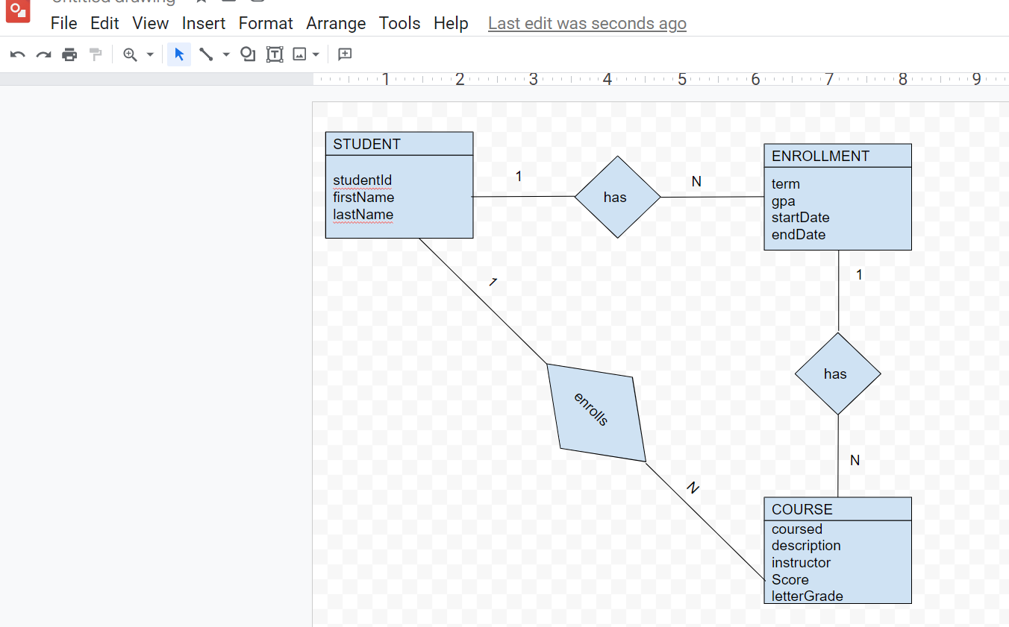

*Convert the proposed ORDs into NoSQL data structures:*

1. a STUDENT has many ENROLLMENT(s)

{

"studentId": "123",

"firstName": "anna",

"lastName": "berry",

"enrollment": [{

"term": "1",

"gpa": "4.0",

"startDate": "9/15/2023",

"endDate": "12/5/2023"

},

{

"term": "2",

"gpa": "3.9",

"startDate": "1/3/2024",

"endDate": "8/25/2024"

}

]

}

1. an ENROLLMENT has many COURSE(s)

{

"term": "1",

"gpa": "4.0",

"startDate": "9/15/2023",

"endDate": "12/5/2023",

"course": [{

"coursed": "religios theory",

"description": "studying the theory of religion",

"instructor": "shantal good",

"score": "92",

"letterGrade": "a"

},

{

"coursed": "algebra",

"description": "studying algebra mathematics",

"instructor": "henry man",

"score": "85",

"letterGrade": "c"

}

]

}

1. a STUDENT ENROLL(s) in many COURSE(s)

{

"studentId": "123",

"firstName": "anna",

"lastName": "berry",

"course": [{

"coursed": "religios theory",

"description": "studying the theory of religion",

"instructor": "shantal good",

"score": "92",

"letterGrade": "a"

},

{

"coursed": "algebra",

"description": "studying algebra mathematics",

"instructor": "henry man",

"score": "85",

"letterGrade": "c"

}

]

}